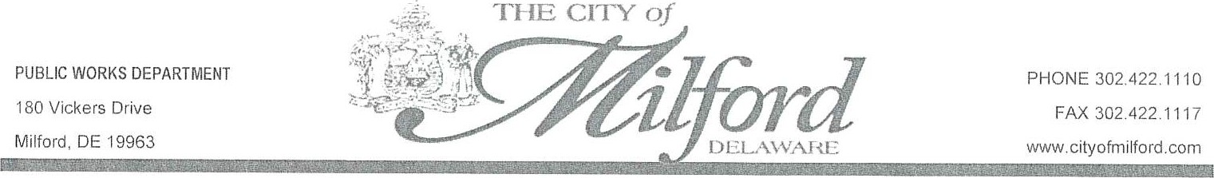

City of Milford – Holiday Collection Changes
The City of Milford will no longer collect yard waste, refuse, or recycling on City holidays. If your scheduled collection falls on a holiday, your items will be collected the following day.
This is not a reduction in service — pickup will simply take place one day later.
For more information, call 302-725-2092.
Rules & Regulations:
Link: https://www.cityofmilford.com/documentcenter/view/4291

2026 Holiday Collection Schedule
Holidays | Type of Collection | Scheduled Collection Date | Revised Collection Date
New Years | Refuse/Recycle | January 1st Thursday | January 2nd, Friday
MLK | Yard Waste | January 19th, Monday | January 20th, Tuesday
Presidents Day | Yard Waste | February 16th, Monday | February 17th, Tuesday
Good Friday | Refuse/Recycle | April 3rd, Friday | April 4th, Saturday
Memorial Day | Yard Waste | May 25th, Monday | May 26th, Tuesday
Juneteenth | Refuse/Recycle | June 19th, Friday | June 20th, Saturday
Labor Day | Yard Waste | September 7, Monday | September 8th, Tuesday
Veterans Day | Refuse/Recycle | November 11th, Wednesday | November 12th, Thursday
Thanksgiving | Refuse/Recycle | November 26/27th, Thursday & Friday | November 28th, Saturday
Christmas Eve & Day | Refuse/Recycle | December 24/25th, Thursday & Friday | December 26, Saturday

Solid Waste Guidelines
Refuse
- All trash must be placed inside closed plastic bags and must fit inside the provided container with the lid fully closed.
- Items placed outside the container will not be collected — schedule a Bulk Collection for oversized items.
- Place containers out by 7:00 AM on collection day.
- Position containers 3 feet away from other objects (poles, vehicles, containers) with the lid opening facing the street.

Recycling
- The following items are never recyclable: tissues, paper towels, wipes, masks, latex gloves, or any sanitary/cleaning materials.
- Break down large cardboard boxes so they fit inside the container.
- Recyclables must be empty, rinsed, and dried.
Food and liquids must never be placed in recycling.

Placement of Containers
- Wheels should face your residence; lid should open toward the street.
- Place containers at the curb edge, ideally on or beside your driveway apron.
- Containers must be 2–3 feet away from parked cars, mailboxes, fences, poles, and other obstacles.
- Place containers side-by-side, not stacked front-to-back.
- Improperly placed containers will not be collected.
Winter Placement
- After snowfall, place containers in your cleared driveway.
- Do not place containers on sidewalks or on top of snowbanks.

Yard Waste
- Yard waste must be placed inside the City-provided brown-lid container.
- Household trash, recycling, or hazardous materials are not permitted.
- Yard waste includes: leaves, grass clippings, twigs, small branches (under 4 ft), shrubbery, pruning, and other garden debris.
- For amounts exceeding the container capacity, see Bulk/Brush Collection below.

Bulk / Brush Collection
- Schedule pickup by calling the Customer Service Office at 302-422-6616.
- Scheduled collections occur on Mondays, except on holidays.
- Each property receives two free collections per calendar year; additional collections are subject to a fee.

Things to Know
- Yard waste, refuse, and recycling will not be collected on City holidays. If your collection day falls on a holiday, pickup will occur the following day.
  - Call Public Works at 302-725-2092 or leave a message at 302-422-1107 for more information.
- Bulk or Brush Collection is available for large household items, brush, or excess trash.

